Kaitlyn Tull A5

W R I T I N G

Dear Reader, as you can see, my project is about writing. At first I wasn’t sure where to go with it, in fact I had absolutely no idea. I would just be sitting at my desk and BAM… I find myself reaching for a pencil and paper. Since my ideas came at random times I decided to make my writing random; but still easy to follow. Writing has always been a huge part of my life; it has always provided me an escape from reality. Whenever I read really enticing literature… I wish with all my heart I could escape into it. You will encounter story ideas hidden in the words (HINT: THEY ARE BOLDED), playlist I listen to when I write, poems in perspective of the story… anything is possible! I feel writing doesn’t have to be boring, in fact to me it isn’t boring; but beautiful. Writing allows you to say what words can’t describe. That’s trademarked by the way XD. I hope you enjoy my random writing, I hope it fills you with a sense of wonder and gives you new if not more respect for writers everywhere!

From,
Kaitlyn Tull

P.S.
“Writing is a socially acceptable form of schizophrenia”. ~E.L. Doctorow

Hear the words…

I remember smearing the words with my hand
I remember the words becoming a part of me
I remember giving life to new friends
I remember getting lost in euphoria

I REMEMBER WRITING MY FIRST STORY

Something’s missing…

YEARN

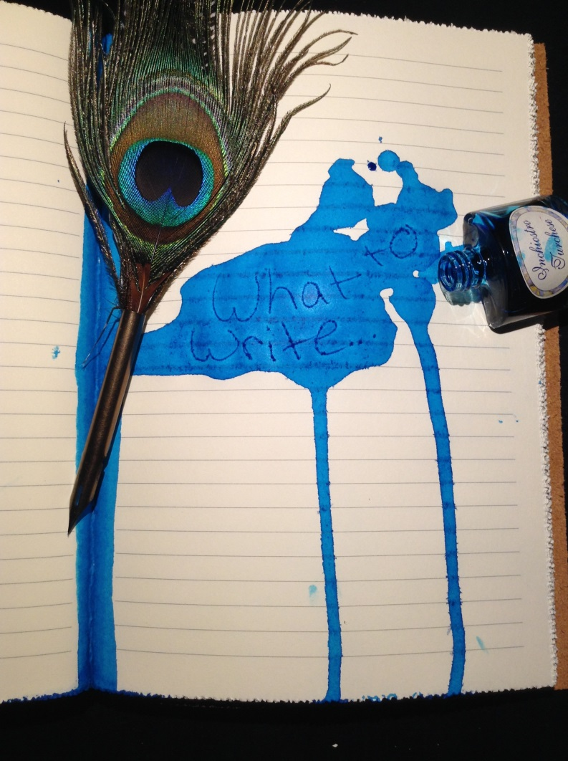
Wanting
Real
Images
To
Internalize
Never
Gone

NOTHING IS MISSING…

Writers Playlist
Nightmare - Avenged SevenFold
Victim - Avenged SevenFold
Mercy - Blood on the Dance Floor
Death to Your Heart! -Blood on the Dance Floor
I’m What Dreams Are made Of – Blood on the Dance Floor
They Say You Won’t Come Back – Breathe Carolina
As the World Falls Down – David Bowie
Martyr – Depeche Mode
A Welcome Burden – Disturbed
Monster - Disturbed
Sacrifice - Disturbed
The Night - Disturbed
Perfect Insanity - Disturbed
Run - Disturbed
Devour - Disturbed
You’re Insane – Escape The Fate
Gorgeous Nightmare – Escape The Fate
Lost in Darkness – Escape The Fate
Teeth – Lady GaGa
Enter Sandman - Metallica
Nature of the Beast – My Darkest Days
Story time – Night Wish
Closer – Nine Inch Nails
The Devil Inside You – Our Last Night
The Girl who Loved the Monsters – Rob Zombie
The Devil’s Rejects – Rob Zombie
Cease to Exist – Rob Zombie
What – Rob Zombie
Cold – Static X
Immortal Love – Vampires Everywhere!
Undead Heart – Vampires Everywhere!
Supermassive Black Hole – Muse

The story… it lacks something

Blurred Lines
I was sitting at my desk, diligently working on my latest story: NIGHTMARE. Out of all my stories, this one spoke to me; seemed to whisper sweet nothings in my ear to keep me motivated. As if I needed it, I would work so late into the night my eyes would tear up from exhaustion and the lines would become blurred… and whenever that happened a sense of wonder enveloped me. In fact that very night I was concentrating so hard, lost in the words, and breathing life into the characters that I didn’t notice my eyes becoming blurred. I was too busy typing and making sure all of my thoughts, all of my ideas were forever imprinted into the computer. It was as if I was numb, and the ONLY thing I could feel was the power, the energy of the words sustaining me. It felt like without them I would drop dead. My eyes darted to the lower right corner of my computer screen to check the time, which read 2:59 A.M. As if on cue my fingers dropped listlessly to my lap, my shoulders hunched, and my breathing slowed. I sat there, staring at my computer screen for what felt like ages. I blinked hard, feeling the tears threatening to spill over. I ever so slowly opened my eyes, and instinctively my hands flew to the keyboard; and it took all my strength not to type. I reached over with my right hand and held the mouse, which had grown cold. I scrolled to the very top until I saw the title: NIGHTMARE; in all its glory. Prying my eyes away from the title I scanned the words as I quickly scrolled through the story. Page after page streamed down the screen, and my excitement grew. When I had reached the last page, where I had stopped just minutes ago, my eyesight went blurry. And for a minute I could have sworn I saw the words dancing to an unknown melody. Blurred lines dancing to the rhythm, the beat, the flow of NIGHTMARE.

IT’S PERFECT

SPELLBOUND

Open me up you’ll find inside
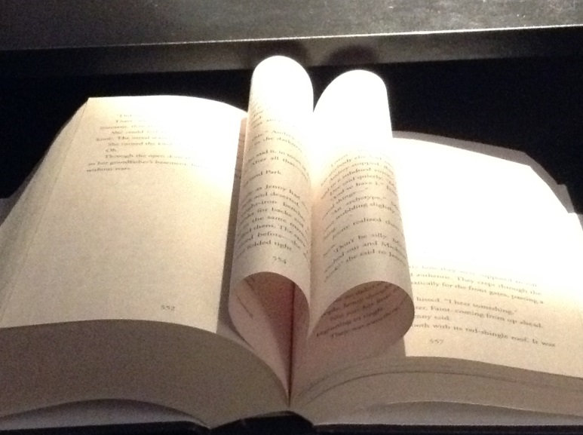
Plenty of places to run and hide

Forget your problems at every turn
In your heart my passions will burn

The joy you feel, the love you have
I have cast a spell now feel my wrath

I carry my secrets on the wind…

I sing the siren’s song

Escape unto me, and you shall see
LOST IN MY PAGES IS WHERE YOU BELONG I feel I messed up

The process
Ink dries on paper
Giving life to new best friends
IMAGINATION
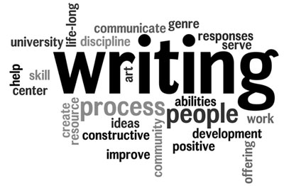

I’M LACKING SOMETHING… LACKING SOMETHING LACKING SOMETHING LACKING SOMETHING LACKING…
CONFIDENCE
Something’s Missing…
Me: Something’s missing, I can feel it
Journal: What do you mean?
Me: Something’s missing
Journal: You have me, a pencil, and your imagination… I don’t quite see what’s missing.
Me: The story, its lacking something
Journal: Hmmm… You have a vampire, I can feel the word
Me: I feel I messed up, that I ‘m not a good writer
Journal: You did not just say that!
Me: It’s true! Great writers are supposed to have this breathtaking image of their story cemented in their mind!
Journal: And you don’t? You have dedicated many hours to this story, dreamt up whole scenes which you have dutifully recorded in me!
Me: Bu…
Journal: And you act out scenes in the shower!
Me: (Blushes
Journal: Nothing is missing, it’s perfect.
Me: You know what… you’re wrong.
Journal: Excuse me?
Me: I can feel it in my heart that something is missing… it haunts me.
Journal: You’re right… people always sugarcoat the truth… and I can tell it’s missing something
Me: What?!? (On verge of tears)
Journal: Confidence… you words lack confidence…

El fin
Hear the words is a Litany poem, meaning a phrase is repeated over and over. In this case I remember is being repeated. This in depth describes my first story I ever wrote. The title just came to me.

YEARN is an Acrostic Poem, the capitalized letters spell a word vertically. This is one of my favorite poems, I WISH SO BAD THAT THINGS IN BOOKS WERE REAL!!!!

WRITER’S PLAYLIST is just that, a playlist XD. It’s my own personal playlist that I listen to everyday for inspiration! It can be classified as a Exposition; it’s not a poem. These songs mean the absolute world to me!

SPELLBOUND is just a poem that came to me. I kept trying to think of a how a book particularly a story lures in its victims. THIS IS MY ABSOLUTE FAVORITE POEM I HAVE EVER IN MY LIFE WRITTEN!!!

THE PROCESS is a Haiku, a poem that has 5 syllables in the first stanza, 7 in the second, and 5 in the last. I feel this is how writing a story should go, first you have the idea (ink dries on paper), introducing new characters (giving life to new best friends) and finally thinking up all kinds of possibilities for your story (IMAGINATION)

SOMETHING’S MISSING is a dialogue. In all of my stories it truly feels like something is missing. When I was writing this, I finally understood that I need to have more self-confidence in myself and my writing.

